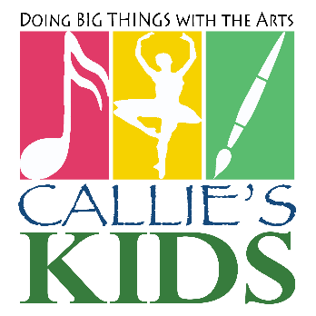
Callie’s Kids Memorial College Scholarships
2021 Application
Callie’s Kids Children’s Foundation is excited to offer our annual Memorial Scholarships. Each award in the amount of $1,000 is open to any high school student who is a resident of Talladega or Clay County and who will be a 2021 graduate of a public or private school located in or close to Talladega County. To qualify, the applicant must meet the following criteria:
Have an overall grade point average of 3.0 or above on a scale of 4.0
Expect to attend a Jr. College or four-year college or university in the fall of 2021.
Priority will be given (but award not limited) to students pursuing a degree in the areas of law, medicine, education or fine arts.
Submit three (3) letters of recommendation (at least one being from a current high school teacher)
Submit a completed application with an official transcript (stamped or sealed by a school counselor or administrator) postmarked no later than March 19, 2021.
Mail applications to: Callie’s Kids, P.O. Box 6402, Talladega, Alabama 35161 (Note: A late or incomplete application packet will not be considered.)

Student’s Name ________________________________ School ______________
Parents/Guardians Name ______________________________________________
Address ________________________________Email_______________________
Student’s Date of Birth ______________ Telephone Number ________________
Grade Point Average ____ ACT/SAT Score ____Class Rank ______ (ex. 5th/120)
Attach a separate sheet for your answers, if necessary.

- List scholarships for which you have applied:

- List any scholarships you have been awarded:

- List any clubs/extracurricular activities in which you have participated (List position or offices held if applicable):

- List community involvement or service in which you have participated:

- List your plans/goals for the next three (3) years:

- List your long-term plans/goals:

- In a single paragraph, describe in your own words why you deserve to receive this scholarship:

